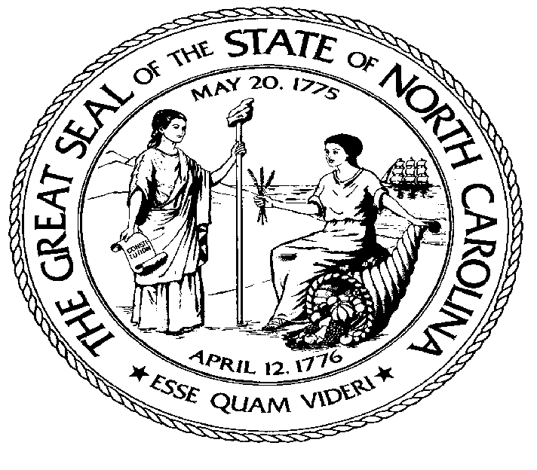  ELAINE F. MARSHALL  SECRETARY OF STATE |  | Page 1 of 3  STATE OF NORTH CAROLINA  DEPARTMENT OF THE SECRETARY OF STATE  Certification and Filing Division  Office of Notary Investigations and Enforcement  P.O. BOX 29626  RALEIGH, NC 27626-0626  PHONE: 919-814-5400 FAX: 919-807-2210  E-MAIL: Notary@sosnc.gov WEBSITE ADDRESS: WWW.SOSNC.GOV

COMPLAINT FORM

The Department has the authority to investigate complaints against any North Carolina Notary when there is an allegation or appearance of violation of Chapter 10B of the North Carolina General Statutes, any rule adopted or any order issued pursuant to this Chapter.

Instructions: Please provide detailed information, be specific and compose clear, concise answers. Please furnish copies of any documents or other materials relating to this complaint. If additional space is needed attach separate sheets and reference the item. Please type or print clearly.

COMPLAINANT INFORMATION

USE TAB OR ARROW KEY

FULL NAME: |  |  |  | DATE OF BIRTH:
 | First Middle Last |  |  |  | MM/DD/YYYY
ADDRESS:
CITY: |  |  | STATE: |  |  |  |  | ZIP:
HOME PHONE: |  |  | BUSINESS PHONE:
CELL PHONE: |  |  | FAX NUMBER:

E-MAIL:

INFORMATION ABOUT THE NOTARY WHICH YOU ARE FILING A COMPLAINT AGAINST

If more space is needed please attach additional pages and reference the item as “Notary Information”

Notary Name |  | Title/Position |  | Notary Address |  | Phone No.

NAME OF NOTARY’S EMPLOYER: |  |  | DBA OR OTHER NAMES IT USES, IF ANY:
ADDRESS OF ORGANIZATION:

CITY: |  |  | STATE: |  |  |  |  |  | ZIP:
PHONE: |  |  | CELL PHONE:
FAX NUMBER: |  |  | E-MAIL:

Page 2 of 3

(If you need more space attach additional sheets and reference the item number.)

- Describe your complaint. Be Specific.

- Describe documents in your possession that relate to your complaint. Please attach copies of all relevant materials to this complaint.

- Have you contacted any other agency regarding your complaint? If so, please provide the name of the agency, address, phone number and contact person.

Agency |  | Address |  | Telephone |  | Contact Person

- Have you contacted the person or organization against which you have a complaint? If so, please provide us with the name of the individual you spoke with and tell us their response. (Please attach copies of any correspondence along with other documents exchanged between you and this entity.)

Page 3 of 3

- Have you contacted a private attorney regarding this matter? If so, please include the attorney’s name, address and phone number.

Attorney Name |  | Address |  | Telephone

- Is court action pending? If so, please furnish the name and location of the court as well as the name, title, and index number of the proceeding. (Please provide copies of any relevant court documents.)

- Are you aware of any person other than yourself that might have or had a similar experience with this notary or who might be able to provide additional information that would be helpful? If so, please provide name, address and phone number, and explain their role below.

Name |  | Address |  | Telephone

- Are you aware of any other names, principles, associates or organizations affiliated with the subject of your complaint that might be able to contribute additional details regarding this matter? If so, please include addresses and phone numbers.

Name of Person or Organization |  | Address |  | Telephone |  | Contact Person for Organization

Please be advised that the North Carolina Department of the Secretary of State Notary Public Section has authority over matters that relate to N.C.G.S. § 10B for the purpose of protecting the public against fraud and forgery by commissioning and regulating notaries public. The function of this section is to investigate accusations of official misconduct on the part of a notary. This agency does not become involved in domestic disputes. This section does not act as your personal attorney nor can we recover money or property for you. If you have questions about your legal rights and responsibilities please consult a private attorney. Please be aware that most information maintained by this Department is public record as a matter of law. By signing below you acknowledge that you are willing to appear in court and testify in this matter if necessary.

Mail the completed form and all documentation to: NC Department of the Secretary of State, Notary Enforcement Section, P.O. Box 29626, Raleigh, NC 27626-0626
Signature |  | Printed Name

Date

