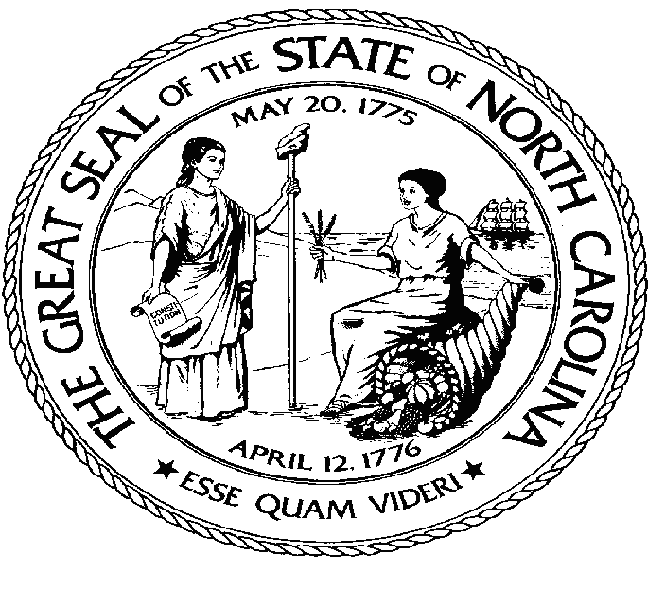
North Carolina Secretary of State - Charitable Solicitation Licensing Division Contact Information:

Agency Website: http://www.sosnc.gov
Email Address: CSL@sosnc.gov; Telephone: (919) 814-5400
Toll Free for NC Residents: 1-888-830-4989 Fax: (919) 807-2220
Mailing Address: Charitable Solicitation Licensing, P.O. Box 29622, Raleigh, NC 27626-0622
Instructions: ANSWER ALL QUESTIONS. This form is to be COMPLETED AND FILED with the Charitable Solicitation Licensing Division
WITHIN 90 DAYS AFTER A SOLICITATION CAMPAIGN HAS BEEN COMPLETED OR ON THE ANNIVERSARY OF THE COMMENCEMENT
OF A CAMPAIGN LASTING MORE THAN A YEAR. Any changes in any information filed with the Department under this section shall be reported in writing to the Department within seven (7) days after the change occurs.

- This form must be submitted directly to Charitable Solicitation Licensing (CSL) .

- Attachment instructions: DO NOT STAPLE OR BIND YOUR DOCUMENTS TOGETHER. Paperclips are acceptable. If an answer requires more space than the form permits, please provide your answer as an attachment identified by the question number or letter.

- Please submit all attachments on "letter"-sized (8.5" x 11") paper.

I. GENERAL INFORMATION FILL OUT COMPLETELY If more space is needed, attach additional pages and reference the item.

A. Name of Solicitor exactly as it appears on North Carolina Solicitor's License | B. N.C. Solicitor's License Number | C. Expiration Date | D. Phone Number
E. Street Address of Solicitor | F. City | G. State | H. Zip Code
I. Name of Charitable Organization or Sponsor for whom solicitations will occur  as it appears on North Carolina Solicitation License | J. Charitable Org. / Sponsor License  Number or Exemption Status | K. Expiration Date | L. Phone Number
M. Street Address of Charitable Organization or Sponsor | N. City | O. State | P. Zip Code

II. CAMPAIGN INFORMATION FILL OUT COMPLETELY If more space is needed, attach additional pages and reference the item.

- Provide the beginning date of the campaign covered in this report. Beginning Date:

- Provide the ending date of the campaign covered in this report. If the
campaign is still in progress, provide the dates covered in this report. Ending Date(s) or
Anniversary Date:

- If this is an annual report of an ongoing campaign, indicate so by checking the "yes" box to the right. If not, check the "no" box. Annual reports must be filed on the anniversary date of the campaign.

YES. NO.

III. GROSS REVENUE AND EXPENSES
Instructions: PROVIDE GROSS REVENUE RECEIVED NATIONALLY AND GROSS REVENUE RECEIVED WITHIN NORTH CAROLINA. PROVIDE NATIONAL EXPENSES AND EXPENSES INCURRED WITHIN THE STATE OF NORTH CAROLINA. COMPLETE ALL SECTIONS.

NATIONAL |  | NORTH CAROLINA  $
A. Gross Revenue  (e.g. Cash, Product Sales, Event Sales, In-Kind Contributions) | $
B. Expenses
Fill out sections 1 - 12 below.
1. Solicitor's Share, Commissions and Fees | $ | $
2. Employee/Independent Contractor Salaries, Fees, Commissions and Benefits | $ | $
3. Professional, Legal, Accounting Fees | $ | $
4. Office Expenses, Rental, Furniture, Equipment, Utilities | $ | $
5. Insurance | $ | $
6. Advertising | $ | $
7. Telephone, Printing, and Postage | $ | $
8. Travel/Vehicle Maintenance/Fuel | $ | $
9. Cost of Merchandise for Resale | $ | $
10. Cost of Show or Entertainment | $ | $
11. Facilities Rental | $ | $
12. Other (Specify) | $ | $
 |  | $
C. Total Expenses  (Total of sections 1 - 12) | $
 |  | $
D. Net Proceeds  (Gross Revenue (A) minus Total Expenses (C)) | $
 |  | $
E. Amount received by Charitable  Organization/Sponsor as a benefit from the solicitation campaign. If (D) and (E) are not equal, attach an explanation. | $
F. Fixed Percentage of Gross Revenue  received by Charitable Organization/ Sponsor as a benefit from the solicitation campaign.  (Amount received by Charitable Organization  (E) divided by Gross Revenue (A)) | % | %

IV. METHOD OF FUNDRAISING Check all that apply.

Door-to-Door Entertainment Event Telemarketing Internet Direct Mail Sale of Products

Other (Explain)

V. SIGNATURE AND NOTARIZATION

I swear or affirm that I am an authorized official of the solicitor and I certify under oath that the information furnished in this financial report and all supplemental forms, reports, documents, and attachments are true and correct to the best of my knowledge under penalty of perjury. SIGN ONLY WHEN IN THE PRESENCE OF A NOTARY PUBLIC.

Signer's Name (Type or Print):
Signature:

Signer's Title or Position:
Notarization: The following is for a notary public to place you under oath and then notarize your signature:

County:
State:

Sworn to and subscribed before me this date of (MM/DD/YYYY):

Notary Public's Signature:

Notary Public's Name (Print):

Date Notary Public's Commission Expires:

If using a notary stamp or seal, stamp or imprint seal in the rectangle below:

PLACE NOTARY SEAL HERE

MAINTAIN A COPY OF THIS FORM FOR YOUR RECORDS

